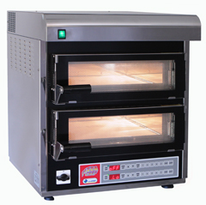

The PIZZACHEF is a compact professional pizza oven, ideal for bars, pubs, pizzerias, fast food outlets, kiosks, beach clubs, etc.
It cooks any type of fresh or frozen pizza to perfection, and much, much more!
The PIZZACHEF oven is available in double and single versions (MP4 and MP5).
In the MP4 model, the two ovens are independent. This means the bottom oven can be used on its own, with the top oven serving as a warming cupboard.
Both versions have a built-in extraction hood, so the oven can even be used by those whose premises do not have a hood.
Cooking temperatures and times for the foods in the individual ovens are set on the electronic display on the front of the appliance.

Pizza in 2 minutes
•
The PIZZACHEF can cook any type of pizza, but with a frozen precooked base finished with a fresh topping just before baking, the results are truly amazing. You can serve a fantastic pizza in just 2 minutes!
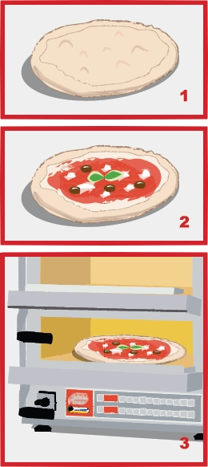

Outstanding electronics!
•
The oven reaches an effective temperature of up to 395° C, the interior is heated both at the top and in the firestone base and the temperature is kept stable both above and below by the graduated electronic control of the heating elements; as the top element warms up, the power of the bottom one is reduced.
This system ensures perfect heat distribution through the oven, for a perfect pizza, crispy underneath and well cooked on top.

SPECIFICATIONS
Power supply: 380 - 400v AC, 50 - 60Hz
• Total power: 4Kw
• Dimensions: 53cm (W) x 61cm (D) x 66cm (H)
• Weight: 58kg
Power supply: 380 - 400v AC, 50 - 60Hz
• Total power: 2Kw
• Dimensions: 53cm (W) x 61cm (D) x 40cm (H)
• Weight: 37kg

