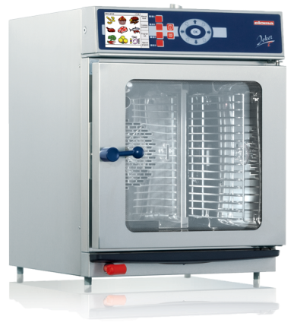
Joker T
The space-saving professional machine
In the little bakery around the corner, at gourmet restaurants, at railway bistros, or even on submarines – the Joker T is at home anywhere. With the technology of the big guys, but in a small space, it offers flexibility and outstanding performance at all levels. This space-saving all-arounder is a real highlight in visual terms, too: it can be integrated perfectly into modern kitchens, and units can be combined next to or above one another without any difficulty. The Joker T comes equipped with a touch control panel, which, with its TFT screen, contains various menu groups and cooking methods, 300 programs and combined load cooking, makes operating it feel like child's play. The Joker T leaves no desire unfulfilled.

Joker T control: Perfected operation - Eloma lives and breathes cooking
•
• High-resolution color monitor with touch technology
• Climatic monitor for setting the oven manually to exactly the right temperature, humidity, time, core temperature, amount of steam, pause times, and fan speed
• 9 cooking methods, 9 menu groups, low temperature and Delta T cooking
• 300 cooking and baking programs, and favorites function
• 5 cleaning programs for all types of grime
• HACCP display showing all data at a glance, data can be archived via PC and LAN interfaces
• Pro-Connect software for creating and managing cooking and baking programs and HACCP data management
• Programs can be adjusted without stopping the machine
• Automatic heating and cooling, with fast cool down feature
• Manual, precise steaming in baking mode
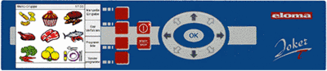

The live steam system - invented by Eloma
•
Live steam is generated by our patented heat recovery system and directly injected into the dispersion tube. This saves energy and creates live steam within seconds without preheating.
Key benefits:
• Perfectly saturated steam quality, precise to the milliliter
• Economical and ecological: greatly reduced cooking times, minimal use of materials, massively reduced energy and water consumption with the very best food quality
• Maximum hygiene thanks to elimination of the boiler and a steady supply of freshly generated steam
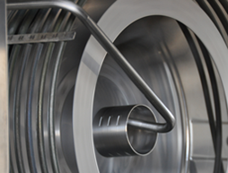

Massive benefits for all users – for professional cooking or baking
•
• Minimal heating time (less than 2.5 minutes to reach 160 degrees Celsius or 152 Fahrenheit)
• Perfect cooking temperature: stable and precise to the degree, even in the lower temperature range
• Energy and water consumption reduced to a minimum
• Significant savings on ingredients thanks to minimised cooking losses and waste
• 50% more capacity thanks to variable tray sizes
• Lightning-fast cooling
• Powerful aroma development, juicy roasts, intensive colors and crispy crusts - all without turning, flipping or rearranging
• Optimisation of product usage thanks to superbly even temperature distribution
• Precise, regular air distribution at all levels
• Perfect combination of cooking parameters
• Optimum temperature conditions for perfect cooking results

Combined load cooking
•
Prepare a range of different products all at the same time with Eloma combined load cooking – quickly, easily and all at once.
• Summary of all meals which can be cooked together - with multiple idependent timer display for each tray
• Cooking times with Eloma combined load cooking can also be controlled using the core temperature: meat dishes that are perfectly cooked inside and out, the best cooking results without stress or time constraining
• Each tray can be programmed individually when fitted with different equipment
• Permanent summary of the remaining cooking times for all dishes and trays
• Visual and acoustic alerts as soon as meals in each tray is ready

Eloma autoclean® – the fully automatic cleaning system
•
The ultimate in hygiene and safety - our unique, patented, fully automatic self-cleaning system.
Your combi steamer takes care of everything on its own at the touch of a button.
• Liquid cleaning system coordinated with Eloma products and ready for use, for optimum cleaning results and the best possible surface protection
• Proven, unsurpassed cleaning results: requiring a minimal amount of time, power and water
• Extremely low cleaning costs thanks to precise measuring of the liquid cleaner
• Maximum safety protection, no direct contact with any cleaning chemicals
• The program can be started at any time without manual cooling or need to open the door
• Perfect cleaning results thanks to a rotary jet
• No more refilling or handling of cartridges or tabs
• Top hygiene standards for products and processes
We recommend our Eloma MULTI-CLEAN products for the best cleaning results and long operating life.
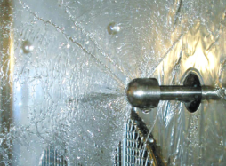

Doors can be hinged on the right or left
•
Perfect ergonomics - we manufacture your machine to suit your requirements.
Only Eloma offers this: no matter where you position your machine, Eloma can adapt it to fit the space you have available. Our machines are available with door hinges on the right-hand side or with a control control panel on the left-hand side.
• Easy to adjust and install
• We offer custom system solutions as an innovative solutions provider
• Outstanding flexibility for all applications thanks to an optimised delivery program
