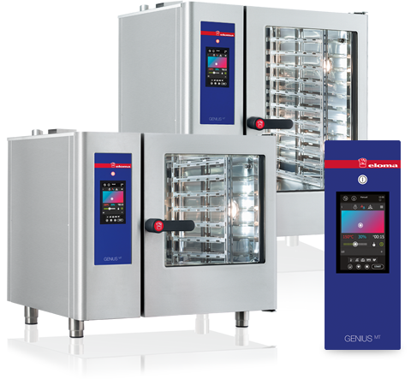
Genius MT
The pro with MT Technology
The future of cooking from Eloma: the combi steamer GENIUS MT delights with its advanced MT Technology which is tailored to various requirements of the out-of-house market, e.g. in restaurants, canteen kitchens and the system catering. Thanks to the high resolution MultiTouch Display and the intuitive controls, it is possible to concentrate on what is important: just cooking! Innovative functions such as Last 20, Multi Cooking or Climatic® MT lend a hand.

Genius MT control: MT Technology
•
Simplify your cooking and baking thanks to MT Technology.
Just slide, wipe or scroll – intuition is the key to operating your GENIUSMT with lightning speed precision.
• High resolution 7" colour monitor with real MultiTouch Technology
• A simple stroke of the finger simultaneously sets temperature and humidity to the exact degree and percentage. Climatic® MT makes it possible.
• The function Last 20 remembers the last 20 cooking processes – nothing is lost.
• Multi Connect makes it easy to interconnect your GENIUSMT: Manage your programmes and HACCP data using advanced communication interface such as USB or LAN.
• A touch with your finger puts all settings exactly where you want them to be thanks to Quick Set.
• System caterers will love Quick Mode. It allows rapid and standard handling in all outlets by means of specifically predetermined operating sequences.
• 9 cooking methods, 9 menu groups, low temperature and Delta T cooking
• 400 cooking and baking programmes, and favourites function
• Automatic logbook function, HACCP display showing all data at a glance, can be archived with PC and LAN interface.
• Various fan speeds
• Programmes can be adjusted without stopping the machine
• Automatic heating and cooling with fast cool down function
• Manual, precise steaming in baking mode
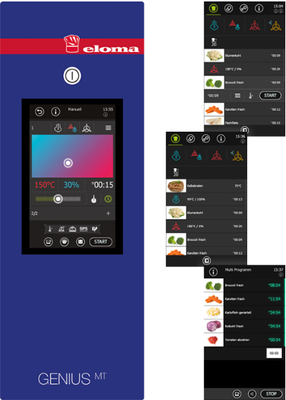

The live steam system - invented by Eloma
•
Live steam is generated by our patented heat recovery system and directly injected into the dispersion tube. This saves energy and creates live steam within seconds without preheating.
Key benefits:
• Perfectly saturated steam quality, precise to the milliliter
• Economical and ecological: greatly reduced cooking times, minimal use of materials, massively reduced energy and water consumption with the very best food quality
• Maximum hygiene thanks to elimination of the boiler and a steady supply of freshly generated steam
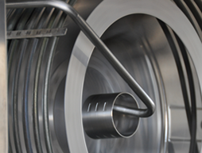

Massive benefits for all users – for professional cooking or baking
•
• Minimal heating time (less than 2.5 minutes to reach 160 degrees Celsius or 320° Fahrenheit)
• Perfect cooking temperature: stable and precise to the degree, even in the lower temperature range
• Energy and water consumption reduced to a minimum
• Significant savings on ingredients thanks to minimised cooking losses and waste
• 50% more capacity thanks to variable tray sizes
• Lightning-fast cooling
• Powerful aroma development, juicy roasts, intensive colours and crispy crusts - all without turning, flipping or rearranging
• Optimisation of product usage thanks to superbly even temperature distribution
• Precise, regular air distribution at all levels
• Perfect combination of cooking parameters
• Optimum temperature conditions for perfect cooking results

Multi Cooking
•
A sure thing. Simply select one programme or cooking method and the GENIUS MT determines all the accompanying programmes required, automatically. Particular benefits:
• Multiple selection for parallel operation, whether before or during the cooking process
• Intelligent time control, set start or end time as desired
• Summary of all meals which can be cooked together – with multiple independent timer display for each tray
• Cooking times with Eloma Multi Cooking can also be controlled using the core temperature: meat dishes that are perfectly cooked inside and out, the best cooking results without stress or time constraining.
• Each tray can be programmed individually when fitted with different equipment
• Permanent summary of the remaining cooking times for all dishes and trays
• Visual and acoustic alerts as soon as meals in each tray are ready
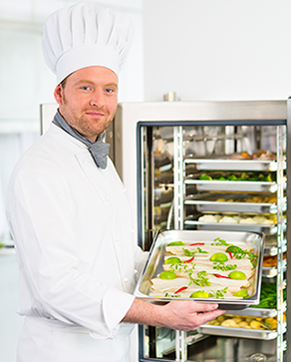

Eloma autoclean® MT – the fully automatic cleaning system
•
The ultimate in hygiene and safety – our unique, patented and fully automatic cleaning system for unsurpassed cleaning results while keeping consumption of water, cleaning and rinsing agents to a minimum.
• Your combi steamer takes care of everything on its own at the touch of a button.
• Liquid cleaning system coordinated with Eloma products and ready for use, for optimum cleaning results and the best possible surface protection
• Proven, unsurpassed cleaning results: requiring a minimal amount of time, power and water
• Extremely low cleaning costs thanks to precise measuring of the liquid cleaner
• Maximum safety protection, no direct contact with any cleaning chemicals
• The program can be started at any time without manual cooling or need to open the door
• Perfect cleaning results thanks to a rotary jet
• No more refilling or handling of cartridges or tabs
• Top hygiene standards for products and processes
The new GENIUS MT now features:
• Quick clean in 15 minutes
• Colour-coded indicator of care product quantities remaining
We recommend our Eloma MULTI-CLEAN products for the best cleaning results and long operating life.
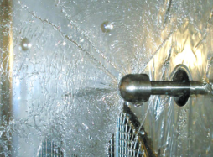

The award-winning multi-eco system
•
Award-winning Eloma technology: be kind to the environment and reduce your operating costs.
• A high-performance heat exchanger can save you up to 16% energy and up to 42% water
• Preheating the steaming water to up to 70°C (158°F) using exhaust heat
• No additional costs for maintenance work
• We are currently the only manufacturer of combi steamers whose multi-eco system has won the Dr.-Georg-Triebe Innovation Prize in the ecology and energy efficiency categories
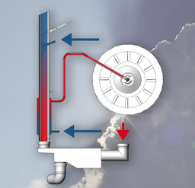

Doors can be hinged on the right or left
•
Perfect ergonomics - we manufacture your machine to suit your requirements.
Only Eloma offers this: no matter where you position your machine, Eloma can adapt it to fit the space you have available. Our machines are available with door hinges on the right-hand side or with a control control panel on the left-hand side.
• Easy to adjust and install
• We offer custom system solutions as an innovative solutions provider
• Outstanding flexibility for all applications thanks to an optimised delivery program
