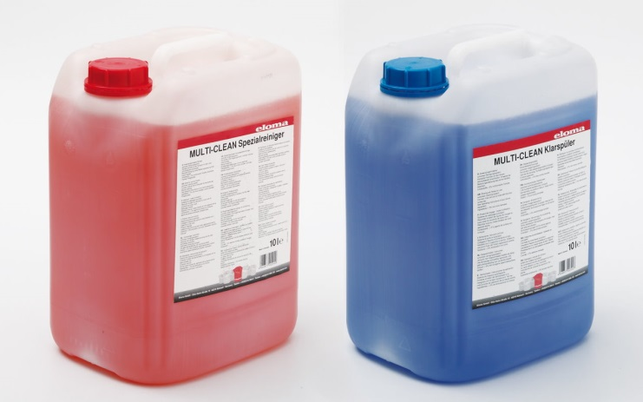
Eloma Multi-Clean
For the best cleaning results and long machine service life: our Eloma MULTI-CLEAN products:
• Eloma MULTI-CLEAN special liquid cleaner
• Eloma MULTI-CLEAN rinser
The Eloma special liquid cleaner and rinser were developed especially for the fully automatic Eloma cleaning system autoclean®.
With this, we offer you outstanding, hygienic cleaning results, even when the cooking chambers are very dirty. You need less liquid cleaner, so you save money as well.
Your autoclean® ensures a long service life for your Eloma machine when used with Eloma MULTI-CLEAN special liquid cleaner and Eloma MULTI-CLEAN rinser.

