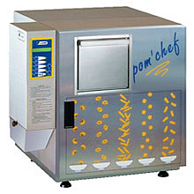

EASY FRY: With our hoodless deep fryers you don’t need a kitchen or a flue!
Automatic deep fryers, perfect for bars, kiosks, take-away outlets and anywhere without a kitchen.
They include a treatment system that eliminates fumes and vapours, transforming them into water, so no extractor hood connection is required.
They are manufactured in two models, which cooks up to 300g and up to 600g of product respectively at a time.

Easy Fry: The user-friendly fryer
•
With EASY FRY, you can cook delicious fried foods in just a few minutes, with no need for a kitchen or a chef.
Your frozen products are always to hand with the drawer freezer, which can also be mounted in a trolley.
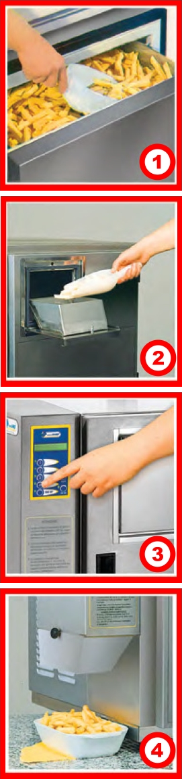

Why buy an Easy Fry deep fryer?
•
To create a new business line in premises not equipped for cooking. They dismantle completely for easier cleaning and no servicing is required. All parts of the appliance are dishwasher-safe, even the seals.
They are automatic appliances, requiring no operator surveillance while foods are cooking!

SPECIFICATIONS
Charging quantity: 300g
• Oil capacity: 5l
• Power supply: 220 - 240v AC, 50 - 60Hz
• Heating power: 2.5Kw
• Total power: 3Kw
• Dimensions: 58cm (W) x 55cm (D) x 57cm (H)
• Weight: 53kg
Charging quantity: 600g
• Oil capacity: 9l
• Power supply: 220 - 240v AC, 50 - 60Hz
• Heating power: 3Kw
• Total power: 3.4Kw
• Dimensions: 58cm (W) x 62cm (D) x 57cm (H)
• Weight: 57kg

