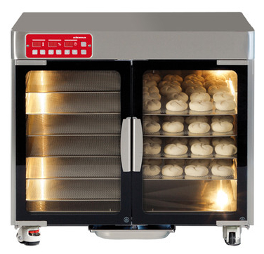
ES160 PROVERS
Features
• Attractive classical oven design creating authentic ambience in sales areas
• Setting up either independently or in combination with Eloma bake ovens BACKMASTER ® to form efficient baking stations
• Large panorama view glass door - design matches Eloma BACKMASTER ®
• Compact dimensions - horizontal controls for limited spaces
• Easy and safe operation
• Clear foil control panel with large digital displays
• Optimal moisture regulation, digital setting from 40% to 90%
• Digital temperature setting from 20° C to 50° C
• Timer 0-99 minutes
• Acoustic sound signal
• Brightly illuminated oven cavity - 4 halogen lamps
• Magnetic door lock - one hand operation - smooth locking and opening
• Automatic water feed with audible and visible indication of water shortage

Construction
• All interior and exterior parts chrome nickel steel CrNi 18 10 - material No. 1.4301
• Security glass panorama door
• Temperature range 20° C to 50°C
• Container collecting condensed water fixed on the outside of the appliance
• Vertically adjustable feet
• Built and controlled in Germany according to quality management system EN ISO 9001

Optional extras
•
• Doors left-hand hinged, no extra charge
• Caster wheels

